Project Report
ON
PROJECT NAME : Different Site of Bangladesh

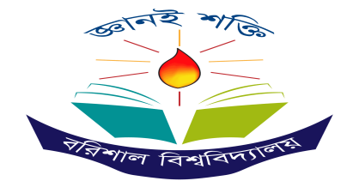
Submitted By
Name:Rupali Akter
Roll:06
Batch:65

structed By:
Name :Dr.Tania Islam
Assistant Professor
Department of Computer Science and Engineering
University of Barishal

EDGE:BU-CSE Digital Skills Training
Computer Fundamental and Office Application

Table of Contents
Chapter 1 3
1.1 3
Introduction 3
1.2 3
Geographical Features of Bangladesh: 3
1.3 4
Population of BANGLADESH 4
1.4 4
Population of BANGLADESH by Division: 4
Chapter 2 5
2.1 5
The Trade of Bangladesh 5
2.2 5
Import Expenditure Chart: 5
2.2.1 6
Export Expenditure Chart: 6
2.2.2 7
Labour export 7
Chapter 3 8
3.1 8
Education of Bangladesh 8
3.2 8
Education system 8
3.2.1 8
Some Public Universities Of Bangladesh 8
3.2.2 9
Some Private Universities: 9
3.3 9
Rules for Calculating Result in the Education System of Bangladesh: 9
Chapter 4 10
4.1 10
Religious of Bangladesh: 10
4.2 11
Conclusion: 11
Chapter 5 11
References: 11

Chapter 1

1.1

Introduction

Bangladesh is a diverse country, ranging from the low lands of the Ganges Delta to the heights of the Chittagong Hill Tracts. The country boasts a number of delightful destinations including cities, national parks, beaches, and rural villages. Each destination has its own appeal and thus it’s a good idea to find out more about them in order to decide where your journey in Bangladesh will lead you.

1.2

Geographical Features of Bangladesh:
Bangladesh is bordered by the Indian states of West Bengal to the west and north, Assam to the north, Meghalaya to the north and northeast, and Tripura and Mizoram to the east. To the southeast, it shares a boundary with Myanmar (Burma). The southern part of Bangladesh opens into the Bay of Bengal. (Graphical Identity of Bangladesh 2025)

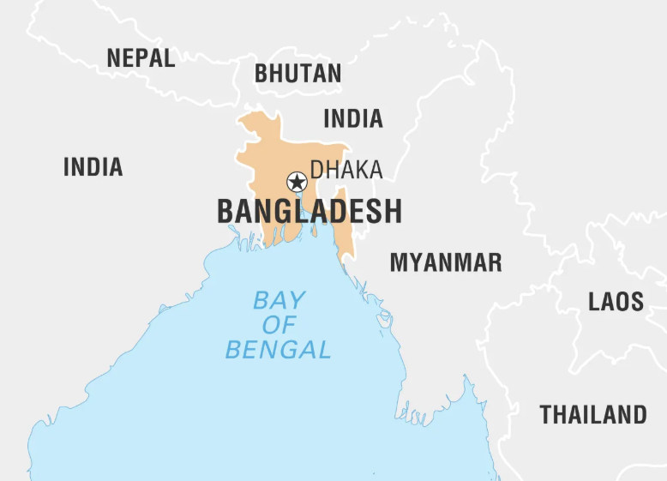

1.3

Population of BANGLADESH

The Bangladesh Population (Live) counter shows a continuously updated estimate of the current population of Bangladesh delivered by Worldometer's RTS algorithm, which processes data collected from the United Nations Population Division.The Population of Bangladesh (1950 - 2024) chart plots the total population count as of July 1 of each year, from 1950 to 2024.The Yearly Population Growth Rate chart plots the annual percentage changes in population registered on July 1 of each year, from 1951 to 2024. This value can differ from the Yearly % Change shown in the historical table, which shows the last year equivalent percentage change assuming homogeneous change in the preceding five year. (Population of Bangladesh)

Year | Total Population | Population Growth Rate
1981 | 7 crores | 1.93%
2011 | 14 crores | 2.34%
2015 | 15 crores | 2.35%
2020 | 16 crores | 2.37%
2023 | 17 crores | 2.75%

1.4

Population of BANGLADESH by Division:

Division | Population
Dhaka | 20,023,000
Chittagong | 14,204,000
Rajshahi | 5,511,000
Khulna | 7,543,000
Barishal | 5,198,000
Sylhet | 4,958,000
Rangpur | 6,765,999
Mymensingh | 4,778,000

Chapter 2

2.1

The Trade of Bangladesh
Overview In 2022, Bangladesh was the number 34 economy in the world in terms of GDP (current US$), the number 52 in total exports, the number 47 in total imports, the number 136 economy in terms of GDP per capita (current US$) and the number 101 most complex economy according to the Economic Complexity Index (ECI) .

2.2

Import Expenditure Chart:
Goods | In The Fiscal Year 2015-16(doller)
Rice | $ 112.00
Oilseeds | $ 945.00
Raw Cotton | $ 532.00
Edible Oil | $ 1,959.00
Fertilizer | $ 1,436.00
Yarn | $ 1,112.00
TOTAL | $ 6,096.00

2.2.1

Export Expenditure Chart:
Year | Export
2007 | $36.10
2008 | $24.05
2010 | $41.87
2011 | $4.17

Some Picture Relate to My topic:
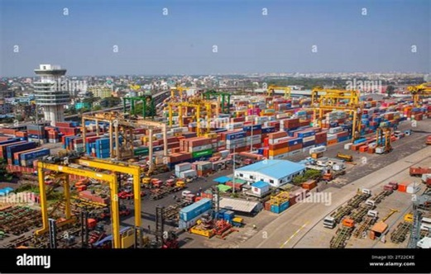
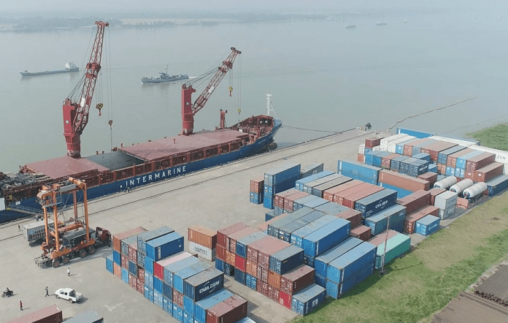
Figure 1:Mongla seaport

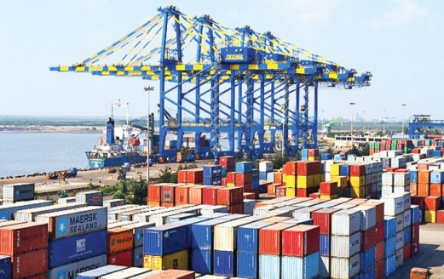
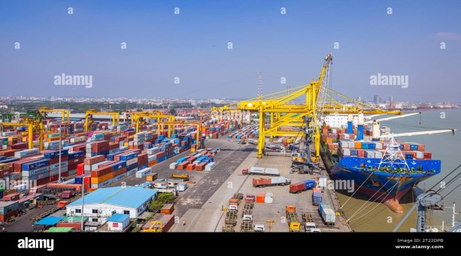

2.2.2

Labour export
secured overseas jobs, building upon last year’s record of 11.35 lakh jobs. Bangladesh has achieved a significant milestone in labour migration, surpassing the 1 million mark in labour exports for the second consecutive year

IN THE CHART WE WILL SEE

Chapter 3

3.1

Education of Bangladesh
Education in Bangladesh is based on a system that was established during the British colonial period1. The system has three levels: primary, secondary, and higher education1 but not all citizens can access them due to various factors. The state finances the education system, but it faces many challenges such as quality, equity, and governance.

3.2

Education system

A Bangladesh education system chart
The main education system is divided into three levels:
- Pre-primary level (class k-2)
- Primary level (class 3–8)
- Secondary level (class 9–12)
- Tertiary level

3.2.1

Some Public Universities Of Bangladesh
KHUL NA
Barishal
Chittagong
Khulna
Dhaka
UNIVERSITY

3.2.2

Some Private Universities:

3.3

Rules for Calculating Result in the Education System of Bangladesh:

Roll No | Student Name | Bangla | English | Math | Science | Total marks | Grade
1 | Reja | 80 | 75 | 90 | 85 | 330 | a+
2 | Setu | 75 | 80 | 85 | 75 | 315 | A
3 | Rupa | 90 | 85 | 88 | 92 | 358 | a+
4 | Sima | 78 | 78 | 87 | 95 | 338 | a+
5 | Tuli | 68 | 77 | 85 | 87 | 317 | A
6 | Mim | 76 | 75 | 84 | 84 | 319 | A
7 | Rokeya | 85 | 79 | 76 | 76 | 316 | A
8 | Beethi | 84 | 85 | 75 | 74 | 318 | A

Chapter 4

4.1

Religious of Bangladesh:
Bangladesh is a land with immense beauty. The country is considered a gem among the lands bordering with the Indian Ocean. Besides being a natural beauty, the country is a land with vibrant communities. People of all creeds and cultures live in harmony in this country. (Wikipedia)

Religious |  |  | Percentage
Islam |  |  | 90%
Hinduism |  |  | 8.50%
Buddhism |  |  | 0.60%
Christianity |  |  | 0.40%

4.2

Conclusion:
Bangladesh stands close to the bottom of the world’s countries in economic development, along with such nations as Chad and Bhutan, which contain only a tiny fraction of its population. The country suffered grievously during its war of independence. Millions streamed across the border into neighboring India. Disruption of transport and of thousands of villages and settlements added to the misery and horror that followed the war from which the country has not since completely recovered.

Chapter 5

References:

Works Cited
computer science. 29 january 25. <https://www.marinetraffic.com/en/ais/details/ports/2743?name=CHITTAGONG&country=Bangladesh>.
Graphical Identity of Bangladesh. 29 january 2025. <https://www.scribd.com/document/510694254/Graphical-Identity-of-Bangladesh>.
Population of Bangladesh. 29 january 2025. <https://www.worldometers.info/world-population/bangladesh-population/>.
wikipedia. 2025.
Wikipedia. 29 january 2025. <https://en.wikipedia.org/wiki/Religion_in_Bangladesh>.
Wikipedia. 29 january 2025. <https://en.wikipedia.org/wiki/Port_of_Chittagong>.

